HCI Android Design Pattern Project



**Project Title:** eTaqreeb

Online Event Organizers

Submitted By:

|  |  |
| --- | --- |
| **Hassan Anwar** | **BSEF12M014** |
| **Muzamil Ejaz** | **BSEF12M054** |
| **Hisham Zahid** | **BSEF12M025** |

Submitted to:

Ma’am Mudassira Arshad

**Search Bar**

User can search vendors by name

Using Search bar

**Dedicated Buttons**

User can view and update its profile info and also logout/login using these buttons

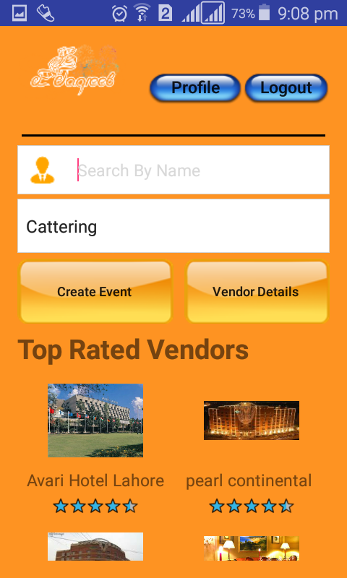

**Slide to Scroll**

To create account as Customer or Vendor

**Dynamic Loading of Data**

Using Gridview to show top rated Vendors

**Rating Stars**

To Rate vendors

**Pan and Scan**

Keyboard comes under the specific field selected for input

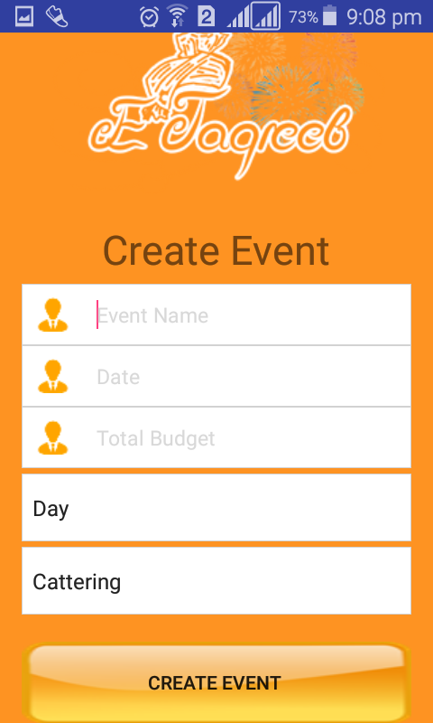

**Date & Time Picker**

To pick date for the specific Event

**Spinner**

To select the predefined shift and specific type (Service) for the event

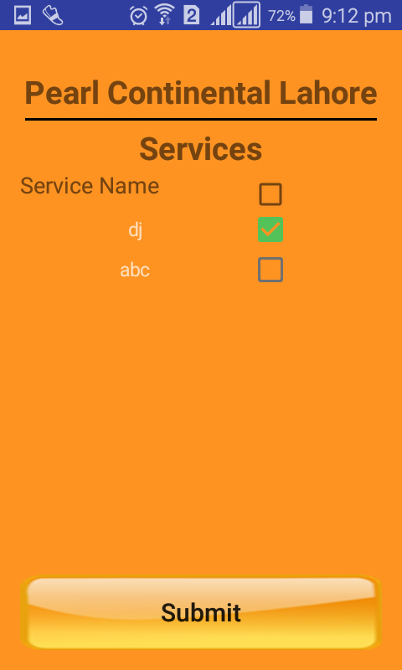

**Checkboxes**

To select multiple services for an event

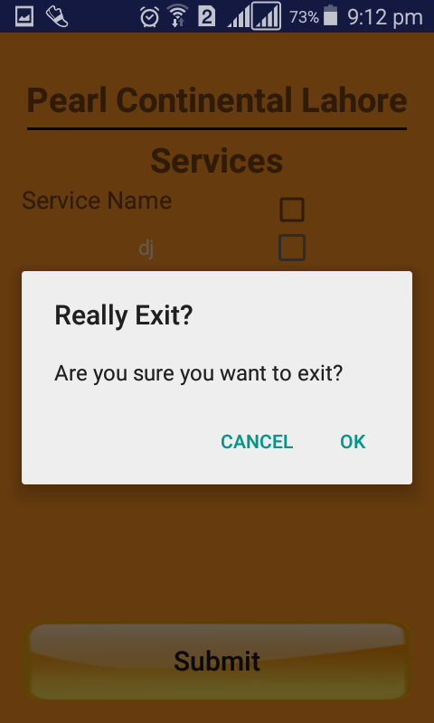

**Alert Dialog**

To show any alert messages

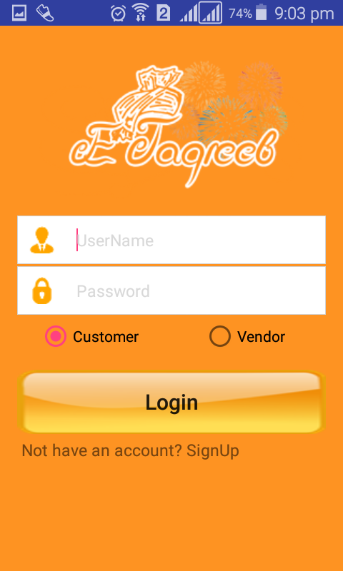

**Login**

To login as customer or vendor

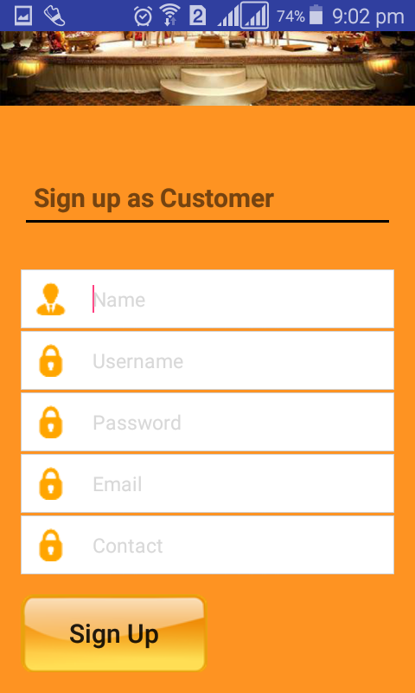

**Create Account**

To create account as Customer or Vendor

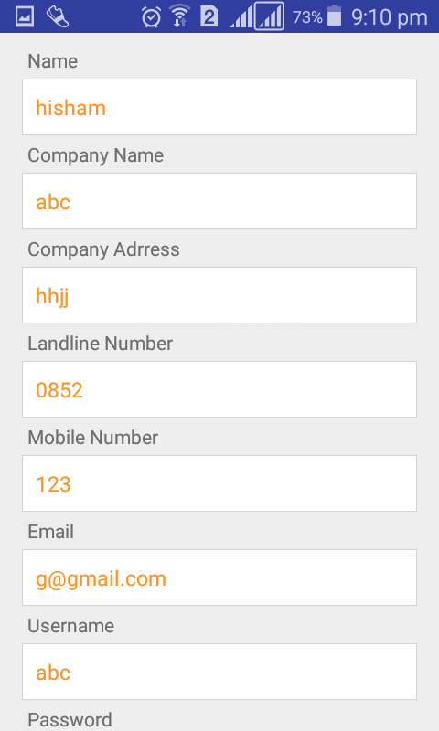

**Slide to Scroll**

To create account as Customer or Vendor

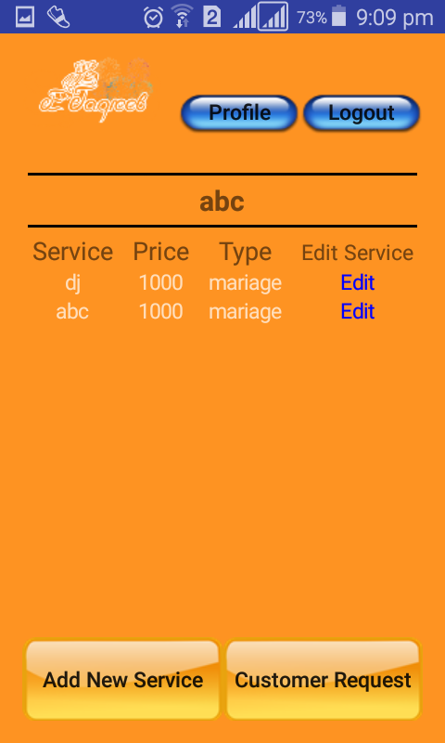

**Double Tap and Zoom**

To zoom event details

**Table**

Display event details in table

**Pinch and Spread**

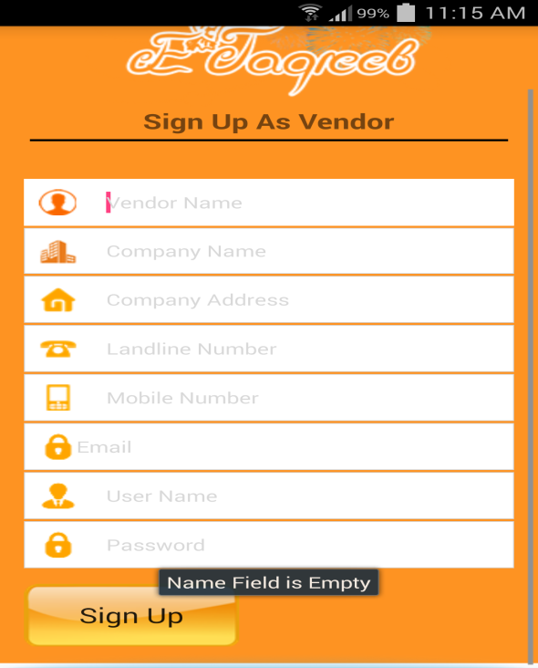

**Toast display**